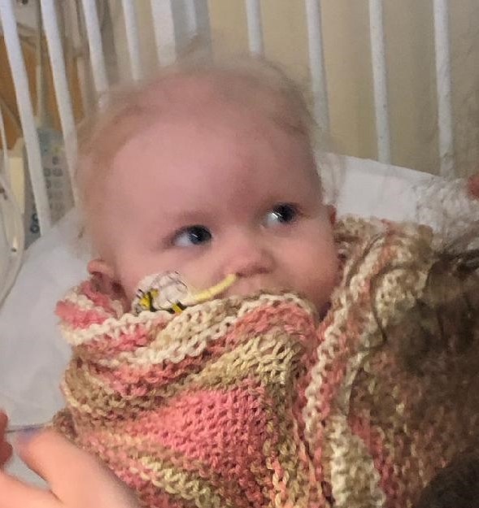
Meet Edith Marie Garneau, with her prayer shawl from Mason Church
Christine Johnson’s daughter, Dezirae, is the mother of Edith, the 11 month old who is at Dartmouth Hitchcock Medical Center in Lebanon being treated for a neuroblastoma tumor.

In prayer for baby Edith, you may find Macrina’s words helpful. From Abide: keeping vigil with the word of God by Macrina Wiederkehr: “Take courage, it is I; do not be afraid. (Matt 14:27) Is this not the voice we all long to hear in the storms of life? These words of Jesus are like an echo from the past, a wake on the waters of life. We may not hear them verbally but somewhere in the marrow of our bones we sense a gracious presence that faithfully surrounds us. A presence that is wholeheartedly for us! God’s promise of faithfulness to us is present in both the Hebrew and the Christian Scriptures. Every time we are commissioned to a new ministry, that same promise follows us or goes before us, like our shadow. The words may differ but the promise of presence pervades.
As you find yourself battling the tempests of daily life, choose one of these encouraging promises as a prayer to follow you through the storm as you, like Peter, walk across the waters to meet Jesus. Listen to God’s voice throughout the ages:
I will be with your (Exod 3:12)
When you pass through the water, I will be with you (Isa 43:2)
Fear not, for I am with you. (Isa 43:5)
I am with you to deliver you. (Jer 1:8)
I will make your name great, so that you will be a blessing. (Gen 12:2)
…What I am trying to highlight for you is that they believed in a sacred presence that was somehow hidden in their own presence. Their belief gave them the strength to trust and to walk through their fears with courage. “ M.Weiderkehr

- Prayer Shawl ministry. Commission yourself to this ministry! Susan Suokko was the amazing shepherd of this mission, and has left it in the hands of the Deacons. We need everyone’s help to continue the mission. If you know of someone who needs a prayer shawl, please let us know. Per Susan’s protocol, we sew a special cross onto the shawl (unless you request otherwise), we adapt our Prayer Shawl Prayer especially to fit the person it’s being given to, and we package it up in a pretty bag for delivery. We will mail one to someone far away, deliver it to the person, or give it to you to deliver. Whatever works! And, of course, we need knitters. If you know someone who knits and wants to contribute, just let us know, and we can provide the yarn. Contact mscott39@gmail.com for info or help.

Upcoming Events

- March 10th Town of Mason voting. Exercise your constitutional right by voting in our local election! 11 am until 7 pm. Don’t know who to vote for? And, take time to come to Town Meeting at 9 am on Saturday, March 14.

- March 12th Thursday 5:30 to 7 pm Community Supper - Bring a friend or yourself, be ready to savor a good meal and enjoy your community! Don’t let food sensitivities keep you home – Each community supper has a gluten-free, dairy-free, and nut-free entrée for our special guests. And you can contribute to the wider community by bringing something canned or boxed for our local food pantry at St Vincent De Paul, and put it in the bin near handicapped entrance—thank you.

- March 14th 3:30pm Nashua Soup Kitchen Meet in the church parking lot at 3:30 for carpooling to Nashua. We are usually back by 6:30 or 7pm. Share your love and energy in this outreach mission of our community. Contact Kathy Chapman, chapman.kathy@gmail.com or 878-4993 if you plan to go or need information. We welcome members of the community in this service mission.

- March 21st 6:30 pm. Living Room Coffee House. Sign up for open mic for music, and share in the bountiful food offerings before the music starts at 7 pm. The folk trio “Oak & Ivy” presents Celtic, original, and American folk music. Members include husband and wife team Jeanne Sable on finger style acoustic guitar and Jim Rodger on harmonica, with Linda Markey on guitar, banjo, bodhran, and dulcimer. The group has performed at various events and open mics throughout the Monadnock region. Markey, of Worcester, MA, is also known for her solo appearances on the Renaissance Fair circuit throughout New England. The trio offers rich vocal harmonies and unique arrangements of traditional and contemporary acoustic songs from America and the British Isles. https://thelivingroomcoffeehouse.wordpress.com/

- Save the date, April 5, 2020 The Mason Energy Commission is holding a Solar How-To presentation on the details of putting up solar for that free energy that we receive every day! See the details on the Town website, or at http://harei.org You may even be able to do it yourself, or knowledgeably contract with a solar company. Come for Soup Supper at 5:30 with the presentation starting at 6:30pm on April 5 in Fellowship Hall, Mason Church.

Remember our church family in your prayers, and in person with a visit, a call, or a card. Loneliness can be relieved, at least temporarily, and price of this “gift” is mostly free!

- Halbrooks family are now at 279 Mountain Road, Jaffrey, NH 03452. Hoping to get the word that they are settled in and ready to have us all come over! Will keep you posted. Meanwhile you can send a snail mail message telling them we are keeping their pew reserved.

- Curt Dunn Curt is at the rehab center Courville, 44 West Webster Street in Manchester. Although he has trouble reading, he still loves cards, but of course, enjoys calls and visits even more. As with his many neighbors in Courville, his health is fragile, so don’t bring any germs with you! Courville phone is 647-5900

- Susan and Jim Suokko moved to Leominster, MA and will be attending a church close to their new home. Their new address is: 50 Brooks Pond Rd, Apt 104, Leominster, MA 01453. As usual, they will be in Florida during the winter months. Their Florida address is Florida: 8814 28th Ave. Palmetto, FL 34221. We miss them, and hope they will visit us this spring.

- Laila Washburn Happy Birthday! March 3rd is Laila’s 101st birthday. Laila lives at Summer Hill Assisted Living in Peterborough. She loves company and cards. At her age every day is treasured. Laila Washburn, Summer Hill, 183 Old Dublin Rd, Peterborough, NH 03458. Call ahead if you have questions. 603-924-6238

- Gretchen and Wally Brown Wally may need some company as much as Gretchen, as her constant care keeps him at home quite a bit. Community Supper Committee will arrange for him to come to the supper, while one of them brings Gretchen the meal and stays to help her as needed. Always in need of a little cheer, Gretchen needs contact with the outside world, so stop by with a smile, a meal, or just to pick up syrup and say hello!
Cards to: 421 Meetinghouse Hill Rd, Mason, NH 03048 phone: 878-1481

- Peggy Lee Welcome to Peggy who worshiped with us recently, and shared our coffee hour social time. She lives in New Ipswich, so help her meet Jean Randle and Helen Emma when she comes again.

- Jacob and his dad, Tom visited with us on 3/1/20, and we hope they will come again sometime. They are residents of Greenville.

- Thank you to everyone who helps with our coffee hour after worship—what great hosts you all are!

Please spread the word about CVTC. It’s free to riders, and the drivers can be reimbursed for gas! A win-win all around. It’s so simple to pick up a trip, give the ride, (make a new friend or two), and the CVTC administration is efficient and kind. Really kind!

